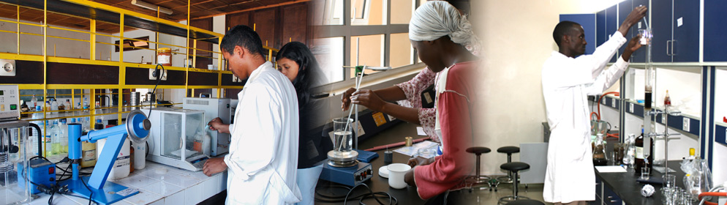

Call for
Proposals
CATEGORY ❷ Accomplished Educational Researcher
Education Research in Africa Award

The Association for the Development of Education in Africa (ADEA) and the African Development Institute (ECAD) of the African Development Bank (AfDB) have launched this call for proposals within the framework of the third round of competition for the Education Research in Africa Award (ERAA), under the aegis of the Korea-Africa Economic Cooperation (KOAFEC).

Purpose
Recognizing the critical role of education in social and economic development, acknowledging the importance of research in the formulation and implementation of educational policy and reforms, and cognizant of the critical role of knowledge, experience, lessons learnt and their tangible impact on the sustainable and inclusive transformation of African economies, ADEA and ECAD/AfDB have created the ERAA.

This award is designed to promote excellence in educational research in African universities, research institutes and networks. It seeks to identify, reward and foster outstanding accomplishments in educational research in Africa, as well as its application in training or capacity building. More specifically, ERAA aims at:
- Strengthening the link between education research and education policy-making and practice in Africa;
- Encouraging and supporting Africa-based researchers and their institutions to produce and disseminate rigorous and relevant research that stimulates innovative policy-making for Africa;
- Facilitating interaction between researchers and policy-makers in order to promote the systematic use of research findings in policy conceptualization, formulation, design, implementation and evaluation;
- Facilitating the identification of strong researchers to provide content for the ADEA Knowledge Hub.

The expected long-term outcome of this award is the institutionalization of a culture of high quality and relevant educational research in Africa that contributes to informed decision-making, and effective implementation of reforms and practice.

Eligibility criteria
An African researcher based in Africa for at least three consecutive years at the time of the submission, and who has gained recognition among peers and/or the education community for his or her research production and impact on education, training or capacity building can compete in this category.

Criteria for evaluating submissions
Research submissions addressing the following thematic areas will receive special consideration: Technical and Vocational Skills Development (TVSD), Early Childhood Development, ICTs, Science, Technology and Innovation (STI), Gender, Peace, Inclusive Education, Teacher Education and the Teaching Profession.

For this third round of competition, special attention will also be given to education, training or capacity building works related to the African Development Bank’s five operational priorities known as High 5s: energy, food and agriculture, industrialization, continental integration and improving the quality of life for the people (see https://www.afdb.org/en/the-high-5/ for more information on these priorities).

The following criteria will be used to assess the quality of entries and select the recipient:
- Has conducted outstanding and sustained research in education, training or capacity building.
- Has evidence of local and international (continental and worldwide) collaboration and networking.
- Excellence of the body of work (originality, conceptual, theoretical, methodological and empirical rigor).
- Relevance and impact of body of work to education policy-making and practice in Africa.
- Evidence of engagement and recognition within a particular professional, scholarly or policy-making community.
- Modes and scope of dissemination of the body of work to the education research community and policy makers.

NB: The submission with the highest grades will be retained for the award. ADEA and ADI/AfDB reserve the right not to give out the award if no submission obtains the pass grade of 75%.

Content of application dossier
- A completed application form (see p. 4 of this call)
- A list of publications, including full references
- Electronic copies of the two most significant publications, including a 2-3 page executive summary
- Curriculum vitae not to exceed 10 single-spaced pages
- Statement (not to exceed 3 single-spaced pages) summarizing the most significant research achievements
- Two letters of support indicating the most significant achievements in terms of the influence or impact of the candidate’s body of work in the area of education, training or capacity building
- Evidence of residence in Africa for three consecutive years at the time of submission.

Language of submission
Submissions are accepted in English or French.

Deadline for submitting application dossiers
Application dossiers must be submitted electronically no later than October 15, 2018 at 11:59 pm GMT to the following address: eraa@afdb.org.

NB: Dossiers received after the above-mentioned deadline will not be considered. Also, any dossier that is incomplete or contains false information will be automatically rejected.

Composition of the award
The award is made up of monetary and in-kind components.

For further information, please send an email to eraa@afdb.org or call Mrs. Raky Gassama at (225) 20 26 12 07.

APPLICATION FORM

CATEGORY ❷ Accomplished Educational Researcher
Education Research in Africa Award

- Surname and first name(s): ______________________________________________________________

- Contact address: ______________________________________________________________________

____________________________________________________________________________________

- Gender: Female  Male 

- Current position: ______________________________________________________________________

- Current institutional affiliation: ___________________________________________________________

- Nationality: __________________________________________________________________________

- Country of residence: __________________________________________________________________

- Language proficiency: (4 = functional native; 3 = advanced professional; 2 = general professional; 1 = limited)
 |  | Speaking | Reading | Writing
 | English
 | French
Others:

- Main research areas/topics: ____________________________________________________________

____________________________________________________________________________________

- Number of publications:
- Refereed articles: _____
- Book chapters: _____
- Books: _____
- Edited journal issues: _____

- Number of MA and doctoral advisees who have graduated during the past ten years:
MA Doctorate
- Total: _____ _____
- Males: _____ _____
- Females: _____ _____
- Disadvantaged/disabled: _____ _____

- Membership of academic and/or professional organizations and networks related to education, training or capacity building:

- Engagement with education, training or capacity building bodies (e.g. boards, committees, etc.):

Signature |  | Date

Awards will be granted in three other categories: emerging educational researcher, outstanding mentor of educational researchers, and enabling institutional environment for educational research.
The referees must be individuals who are in a position to assess the value of the candidate’s work for the scientific community and/or for policy and practice. They must send their letters directly to the email address provided below. It is the candidate’s responsibility to request these letters and inform her or his referees about the eligibility and evaluation criteria, as well as the deadline for submitting application dossiers.

