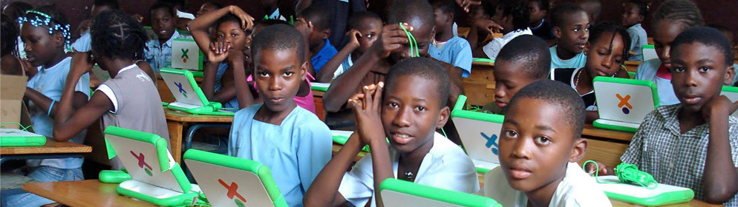

Call for
Proposals

CATEGORY ❸ Outstanding Mentor of Educational Researchers
Education Research in Africa Award

The Association for the Development of Education in Africa (ADEA) and the African Development Institute (ECAD) of the African Development Bank (AfDB) have launched this call for proposals within the framework of the third round of competition for the Education Research in Africa Award (ERAA), under the aegis of the Korea-Africa Economic Cooperation (KOAFEC).

Purpose
Recognizing the critical role of education in social and economic development, acknowledging the importance of research in the formulation and implementation of educational policy and reforms, and cognizant of the critical role of knowledge, experience, lessons learnt and their tangible impact on the sustainable and inclusive transformation of African economies, ADEA and ECAD/AfDB have created the ERAA.

This award is designed to promote excellence in educational research in African universities, research institutes and networks. It seeks to identify, reward and foster outstanding accomplishments in educational research in Africa, as well as its application in training or capacity building. More specifically, ERAA aims at:
- Strengthening the link between education research and education policy-making and practice in Africa;
- Encouraging and supporting Africa-based researchers and their institutions to produce and disseminate rigorous and relevant research that stimulates innovative policy-making for Africa;
- Facilitating interaction between researchers and policy-makers in order to promote the systematic use of research findings in policy conceptualization, formulation, design, implementation and evaluation.
- Facilitating the identification of strong researchers to provide content for the ADEA Knowledge Hub.

The expected long-term outcome of this award is the institutionalization of a culture of high quality and relevant educational research in Africa that contributes to informed decision-making, and effective implementation of reforms and practice.

Eligibility criteria
An African (based in Africa) who is an accomplished researcher, recognized for his or her contribution to strengthening research capacity through supporting the professional development of Africa-based educational researchers can compete in this category.

Criteria for evaluating submissions
The following criteria will be used to assess the quality of the submissions and select the recipients:
- Track record of mentorship (number of mentees, especially from currently or previously disadvantaged groups, such as women, minorities or poor communities; length and continuity of engagement in mentoring; professional advancement of mentees; mentoring entry level professionals in the development of educational research skills, opportunities to publish, accessing financial resources and networking within professional organizations.)
- Scope of achievements in educational research, policy and practice at various levels in addition to mentoring researchers.
- Recognition for his or her mentoring capabilities.

NB: The submission with the highest grades will be retained for the award. ADEA and ADI/AfDB reserve the right not to give out the award if no submission obtains the pass grade of 75%.

Nomination and application process
- Nomination
  - A group of mentees or colleagues may nominate a candidate by filling and sending the nomination form (see p. 4 of this call) to the following address: eraa@afdb.org.
  - The Scientific Committee contacts nominee.
  - If nominee accepts nomination, then he or she must submit a dossier that contains the following:
- Nominee information form (see p. 6 of this call)
- Curriculum vitae not to exceed 10 single-spaced pages
- A statement, not to exceed 3 single-spaced pages, summarizing the most significant achievements as a mentor and educational researcher.
- A sample of research outputs carried out in collaboration with mentees, including abstracts (maximum 3).

Language of nomination and submission
Nominations and submissions are accepted in English or French.

Deadline for submitting application dossiers
Application dossiers must be submitted electronically no later than October 15, 2018 at 11:59 pm GMT to the following address: eraa@afdb.org.

NB: Dossiers received after the above-mentioned deadline will not be considered. Also, any dossier that is incomplete or contains false information will be automatically rejected.

Composition of the award
The award is made up of monetary and in-kind components.

For further information, please send an email to eraa@afdb.org or call Mrs. Raky Gassama at (225) 20 26 12 07
NOMINATION FORM

CATEGORY ❸ Outstanding Mentor of Educational Researchers
Education Research in Africa Award

- Surname and first name(s) of the applicant: ________________________________________________

- Gender: Female  Male 

- Current position: ______________________________________________________________________

- Current institutional affiliation: __________________________________________________________

- Nationality: __________________________________________________________________________

- Country of residence: __________________________________________________________________

- Justification for nomination (not to exceed 200 words):

- Name & address of leader of group nominating:

____________________________________________________________________________________

____________________________________________________________________________________

____________________________________________________________________________________

Signature |  | Date

NOMINEE INFORMATION FORM

CATEGORY ❸ Outstanding Mentor of Educational Researchers
Education Research in Africa Award

- Surname and first name(s): _____________________________________________________________

- Contact address: _____________________________________________________________________

____________________________________________________________________________________

- Gender: Female  Male 

- Year doctorate obtained: _______________________________________________________________

- Current position: ______________________________________________________________________

- Current institutional affiliation: __________________________________________________________

- Nationality: __________________________________________________________________________

- Country of residence: __________________________________________________________________

- Language proficiency: (4 = functional native; 3 = advanced professional; 2 = general professional; 1 = limited)
 |  | Speaking | Reading | Writing
 | English
 | French
Others:

- Main research areas/topics: ____________________________________________________________

____________________________________________________________________________________

- Number of publications:
- Refereed articles: _____
- Book chapters: _____
- Books: _____
- Edited journal issues: _____

- Number of MA and doctoral advisees who have graduated during the past ten years:
MA Doctorate
- Total: _____ _____
- Males: _____ _____
- Females: _____ _____
- Disadvantaged/disabled: _____ _____

- Number of mentees (beyond graduation) during the past ten years:
- Total: _____
- Males: _____
- Females: _____
- Disadvantaged/disabled: _____

- List and full contact information of the most outstanding mentees (up to five):

Surname & first name(s) | Address (including email address)

- Membership of academic and/or professional organizations and networks related to education, training or capacity building:

- Engagement with education, training or capacity building bodies (e.g. boards, committees, etc.):

Signature |  | Date

Awards will be granted in three other categories: emerging educational researcher, accomplished educational researcher, and enabling institutional environment for educational research.
Research submissions addressing the following thematic areas will receive special consideration: Technical and Vocational Skills Development (TVSD), Early Childhood Development, ICTs, Science, Technology and Innovation (STI), Gender, Peace, Inclusive Education, Teacher Education and the Teaching Profession. For this third round of competition, special attention will also be given to education, training or capacity building works related to the African Development Bank’s five operational priorities known as High 5s: energy, food and agriculture, industrialization, continental integration and improving the quality of life for the people (see https://www.afdb.org/en/the-high-5/ for more information on these priorities

